Help for DHI NetCDF Tool

# Introduction and Disclaimer

This program converts structured grid NetCDF and GRIB2 files with CF convention (<http://cfconventions.org/>) to MIKE DFS files and vice versa.

Other NetCDF files which are non-compliant with CF convention will not work, however additional modifications is possible to enable the conversion of non CF convention NetCDF files to DFS files on a request basis. For such requests, please contact [mike@dhigroup.com](mailto:mike@dhigroup.com).

The NetCDF files written by this program also follows the CF convention.

*Note: Automatic mapping between DHI EUM items and CF standard table names are done as much as possible but will require user input if no matches are found.*

# System Requirements

This program will only function if there is MIKE 2016 installed on your system. To download MIKE 2016, visit <https://www.mikepoweredbydhi.com/download/mike-2016>

# Options

This program contains 3 different options

1. **Windows Form** - running the exe file without any arguments will bring up a windows form which quickly guides the user on how to run the program.

It is also the form to save the configuration settings file. This configuration settings file is required for running batch processes.

1. **Command line** - running the exe file with “-auto settingsfilename.xml” will run the stored command(s) and settings saved in the configuration settings file
2. **Command line** - running the exe file with “-autoprefix settingsfilename.xml” will run the stored command(s) and use the prefix settings for input and output files

# Examples

## Converting NetCDF to DFS2

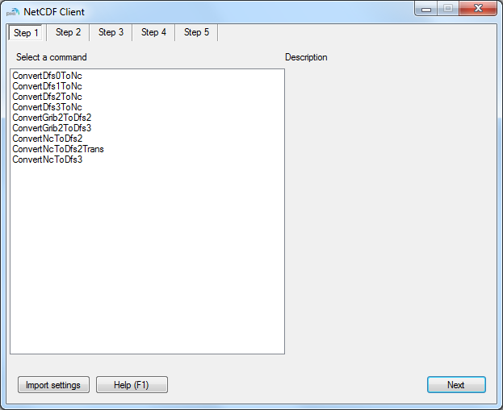

Figure 1 Step 1 Example of converting a NetCDF file to a dfs2 file.

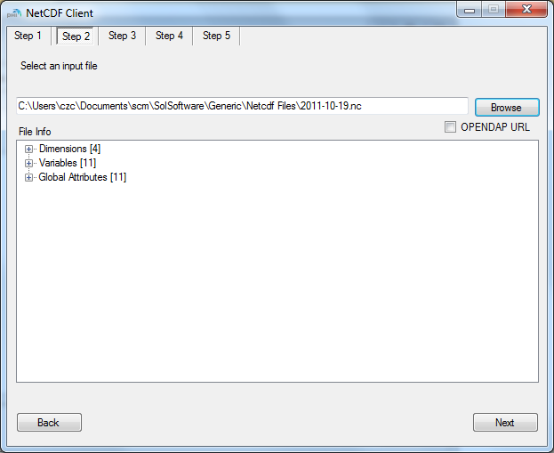

Check this box if the data is a URL from OPENDAB

Figure 2 Step 2 Selecting a NetCDF file and table view of file information

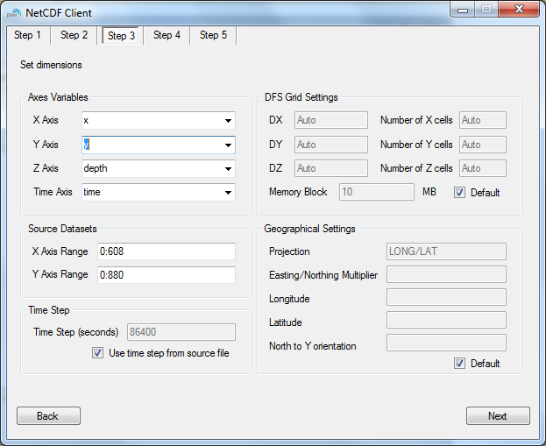

You can also change the geographical settings of the DFS file if necessary

You can change the grid settings of the DFS file if necessary.

Make sure that the axes are correctly set.

You will see the range of the dataset under “Source Datasets” if the axes are correct

Figure 3 Step 3 Set dimensions

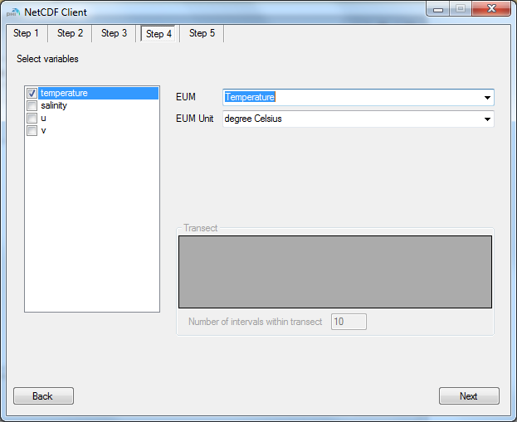

This option will only be enabled if you are converting to a DFS2 transect file.

Figure 4 Step 4 Selecting the parameters to be converted. If the variable in the NetCDF file is mapped properly, it will appear in the EUM textbox with the correct EUM unit.

Note: The coordinates of the transect points in the transect option are the same as the selected axes which are chosen in Step 3.

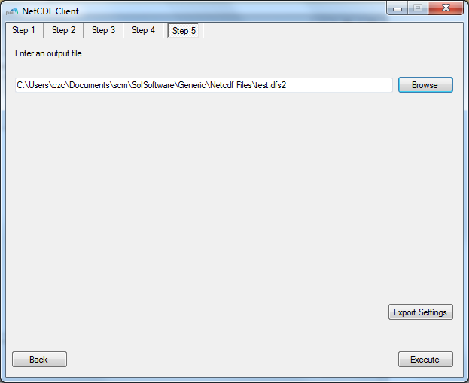

You can save the configuration settings in an xml file by clicking on Export Settings.

Figure 5 Step 5 Save and Execute.

## Converting a DFS2 file to NetCDF

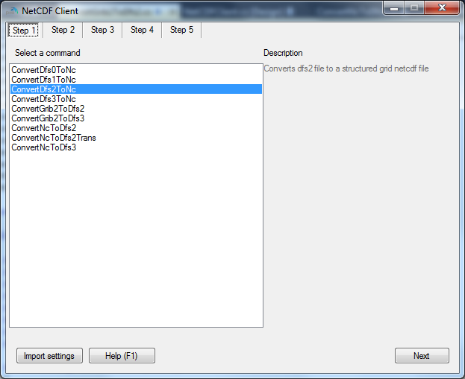

Figure 6 Step 1 Example of converting a dfs2 file into a 2D netcdf file.

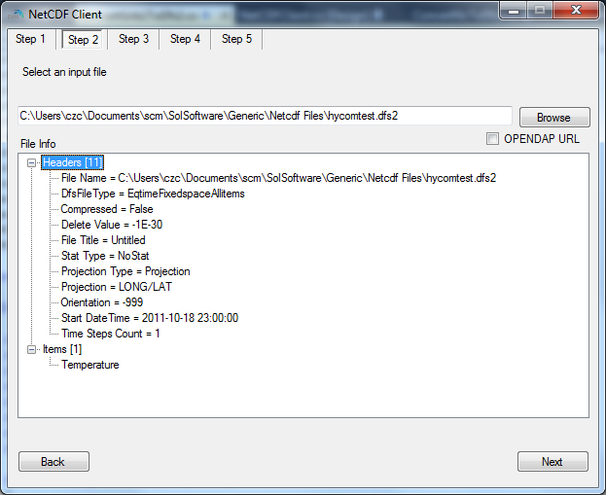

Figure 7 Step 2 selecting a dfs file (in this case dfs2) and a table view of the contents

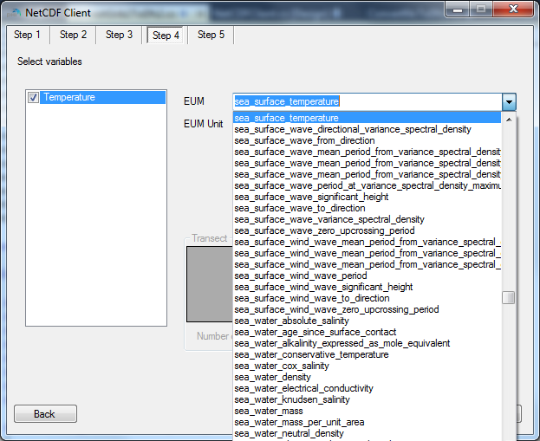

Figure 8 Step 4 selecting the items to be saved as NetCDF. Items are saved with DHI item names with CF standard long names. A list of closest matching CF standard long names is presented for the user to select. Step 3 is skipped as dimensions for NetCDF files are automatically generated from the dfs file.

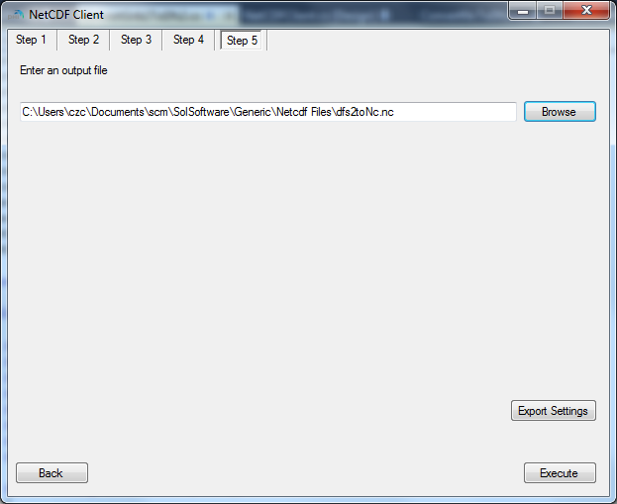

Figure 9 Step 5 Save and Execute. Click on “Export Settings” to keep a copy of all the options which have been entered from step 1 to step 5. Click on execute to run the process.

## Command Line Example

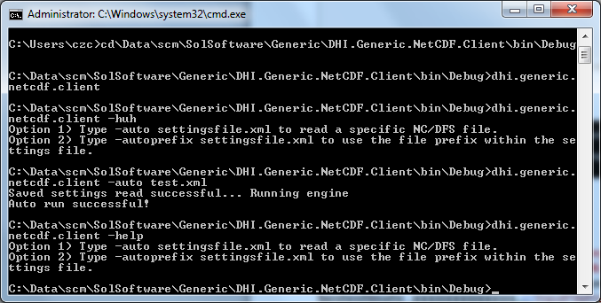

Figure 10 Typing DHI.Generic.Netcdf.Client –help brings out a list of commands

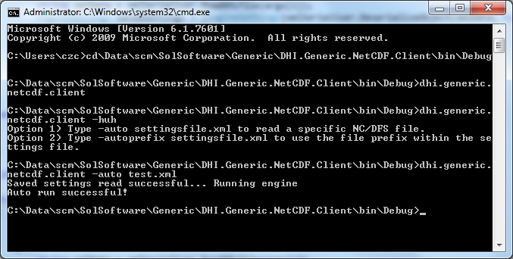

Figure 11 Example of running the program using –auto command.